NAME:

Answer the following questions showing all work. Full credit will not be given to answers without work shown. If you use Minitab Express or StatKey include the appropriate output (copy + paste). If you do hand calculations show your work using the Word equation editor. Clearly identify your final answers. Output without explanation will not receive full credit and answers with no output or explanation will not receive full credit. Round all answers to 3 decimal places. If you have any questions, post them to the course discussion board.

1. A representative sample of 100 World Campus STAT 200 was surveyed. Each student was asked if they work full-time, part-time, or if they’re no employed. In that sample 100, 46 were working full-time, 32 were working part time, and 22 were not employed. Use the five-step hypothesis testing procedure to determine if there is evidence that the proportions of World Campus STAT 200 students in the population who work full-time, part-time, and who are not employed are not all equal. Use Minitab Express and remember to include all relevant output. [20 points]

Step 1: the null hypothesis
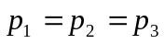
the alternative hypothesis
The proportions are not all equal
Step 2: t statistic 11
Step 3: the p-value
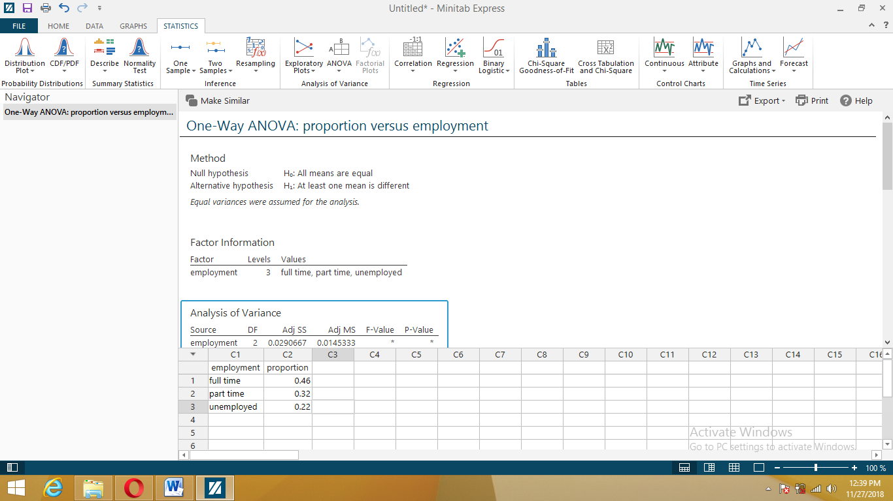
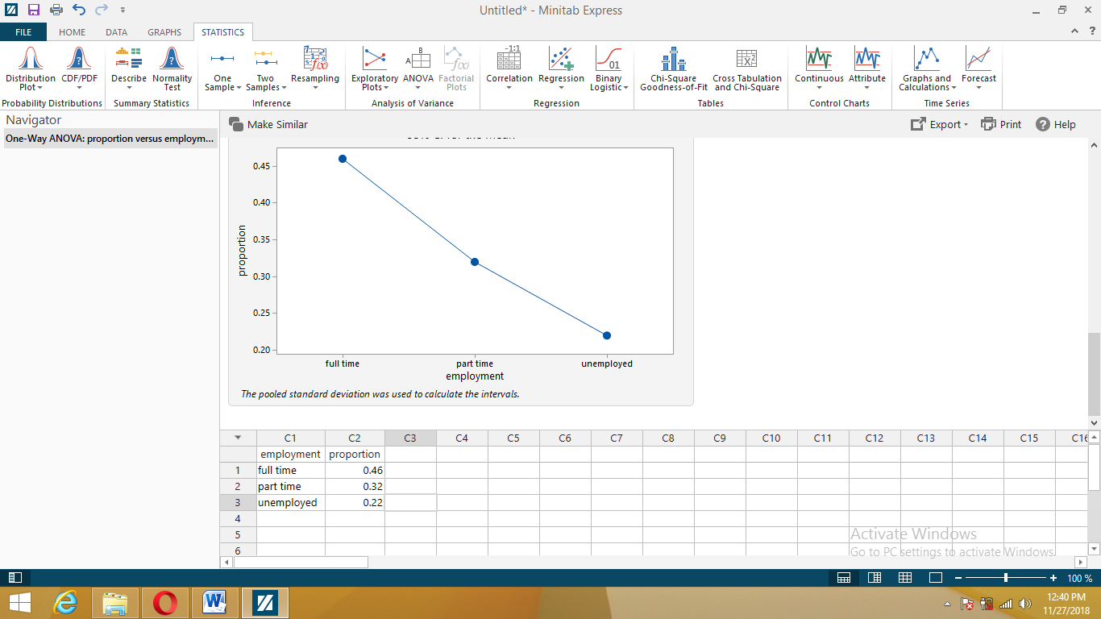
P value= 0.0001
Step 4:
Reject the null hypothesis
Step 5:
there is evidence that the proportions of World Campus STAT 200 students in the population who work full-time, part-time, and who are not employed are not all equal.

2. In StatKey, in the “More Advanced Randomization Tests” row, select “χ² Goodness-of-Fit.”
Click “Edit Data” and copy + paste the following data:
Option, Count
A, 1
B, 4
C, 8
D, 3
E, 4
These are the counts associated with the correct answers on a 20 question multiple-choice quiz. Each quiz question has five options. We suspect that the instructor does not evenly weight the answers. [30 points]

A. In this scenario, has the assumption for using the chi-square distribution to approximate the sampling distribution been met? Explain why or why not.
Yes, the one categorical valuable with more than 2 categories condition has been met
B. Use StatKey to generate 5,000 randomization samples. Paste a screenshot of your randomization distribution here.

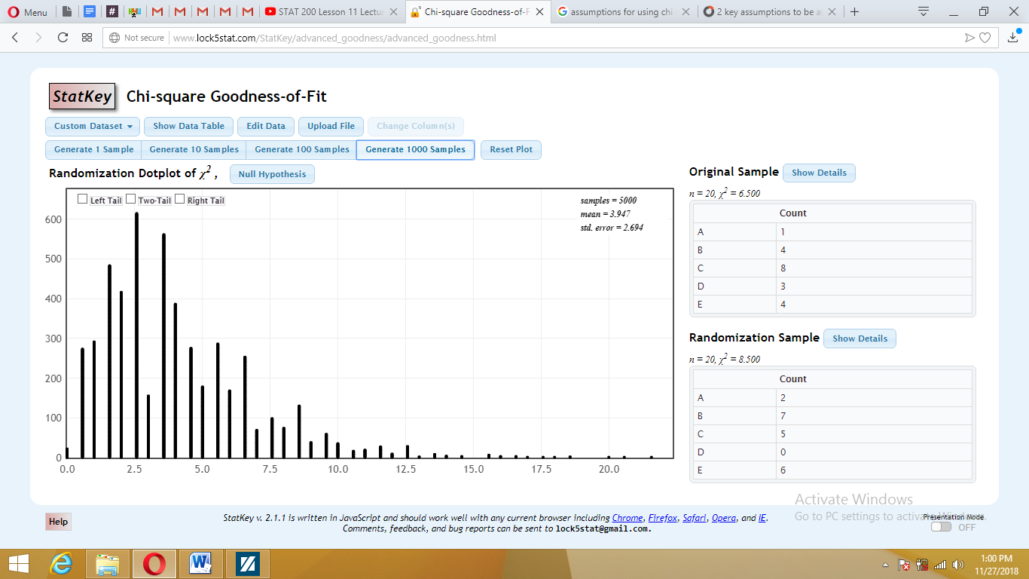
C. Describe the shape of your randomization distribution.
Skewed to the right
D. Use your randomization distribution to determine the p-value for this test. Include a screenshot of your randomization distribution with the p-value area shaded in.
(Hint: The p-value is still the area more extreme than your observed statistic. Remember that a chi-square test is always right-tailed).
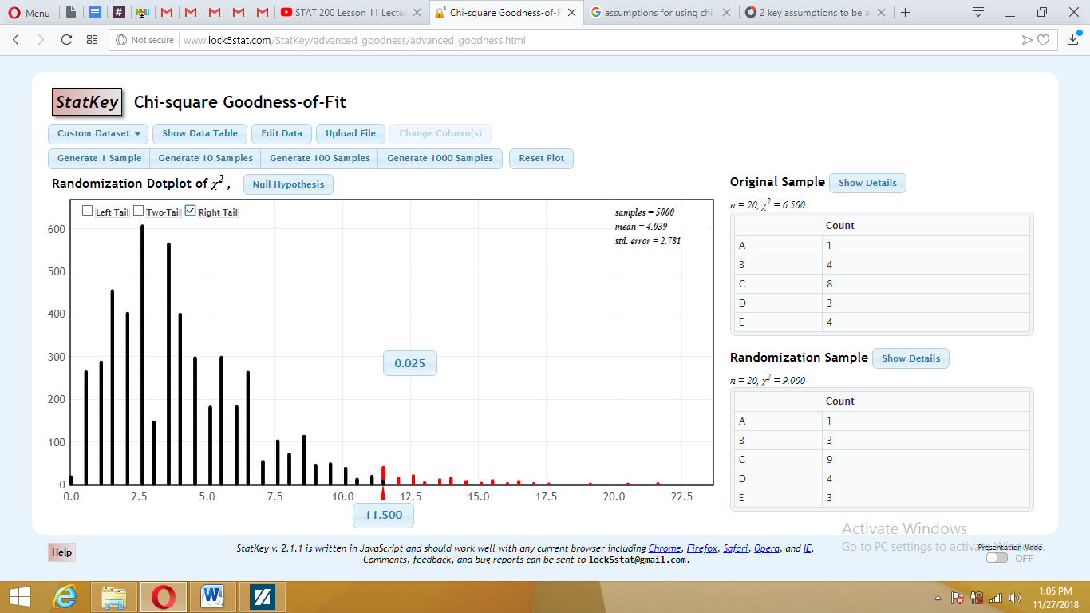
E. Is there evidence that the instructor does not evenly weight the five answer options? Explain why or why not.
No there is no evidence. This is because the p value is greater than the alpha thus we fail to reject the null.

3. Use the file Gender.MTW to answer the following questions concerning gender and learner status (adult learner versus traditional student). Assume this sample is representative of the population of all online STAT 200 students during the summer semesters. [50 points]

A. Construct a contingency table of gender and learner status.

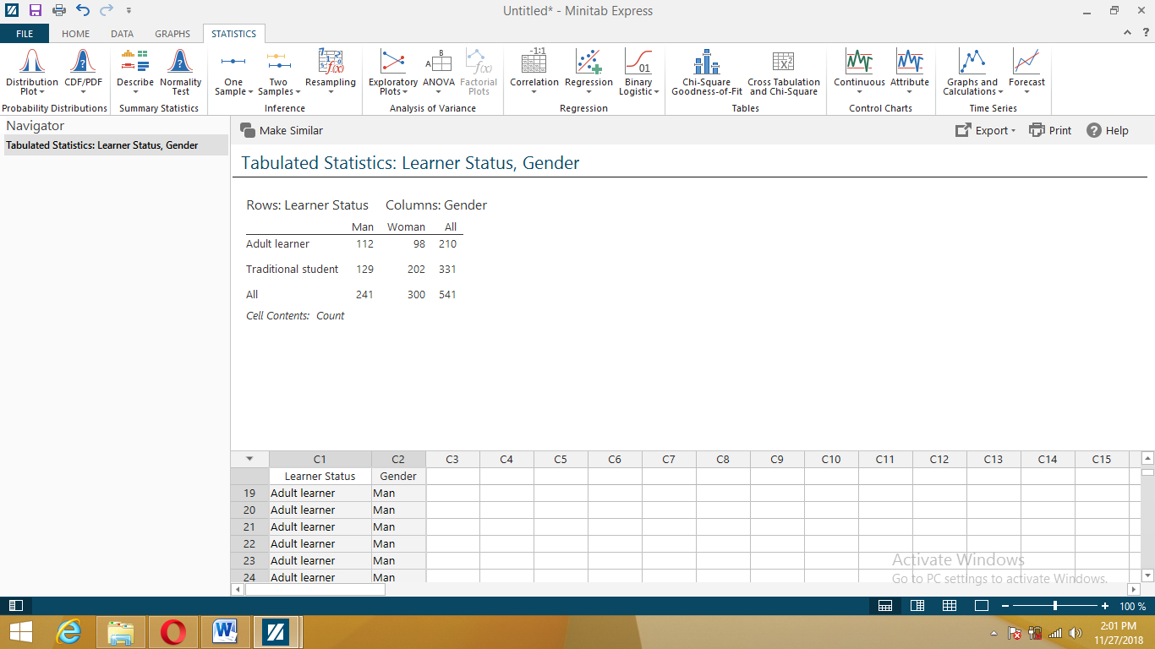
B. What proportion of men in this sample were adult learners?
0.533

C. What proportion of women in this sample were adult learners?

0.467
D. Given the proportions that you computed in parts B and C, are gender and learner status independent in this sample? Explain why or why not.
Yes they are. The proportion adds to 1.

E. Compute the “relative risk” of being an adult learner for men compared to women.
Relative risk= risk in group 1/ risk in group 2
0.533/0.467= 1.141

F. How would you interpret the value that you computed in part E for a friend with no knowledge of statistics?
Adult Men are 1.141 times more likely to be learning than adult women.

G. Conduct a chi-square test of independence to determine if there is evidence of a relationship between gender and learner status in the population of all summer online STAT 200 students. Use the five-step hypothesis testing procedure.
Step 1:
Null hypothesis. There is not a relationship between gender and learner status in the population of all summer online STAT 200 students.

There is a relationship between gender and learner status in the population of all summer online STAT 200 students.
Step 2:
The test statistic is 10.73
Step 3:
The p value
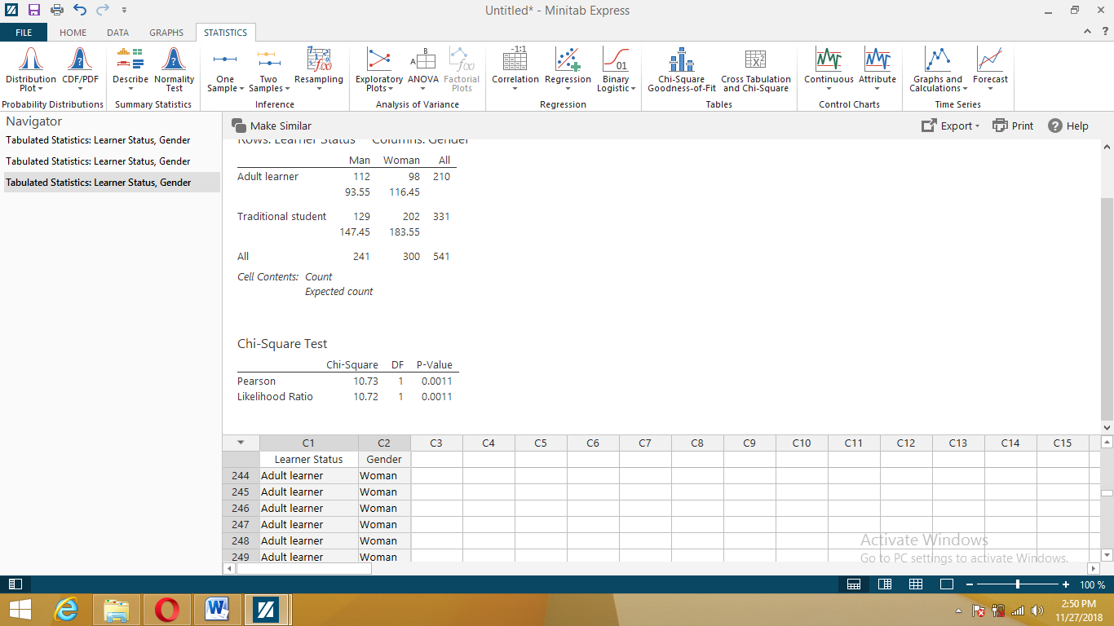
0.0011
Step 4:
Reject null hypothesis
Step 5:
There is a relationship between gender and learner status in the population of all summer online STAT 200 students.

H. In your chi-square test in part G, which cell made the largest contribution to the chi-square test statistic? (Hint: Construct a contingency table and in the “display” tab check the box to display “Each cell’s contribution to chi-square”)
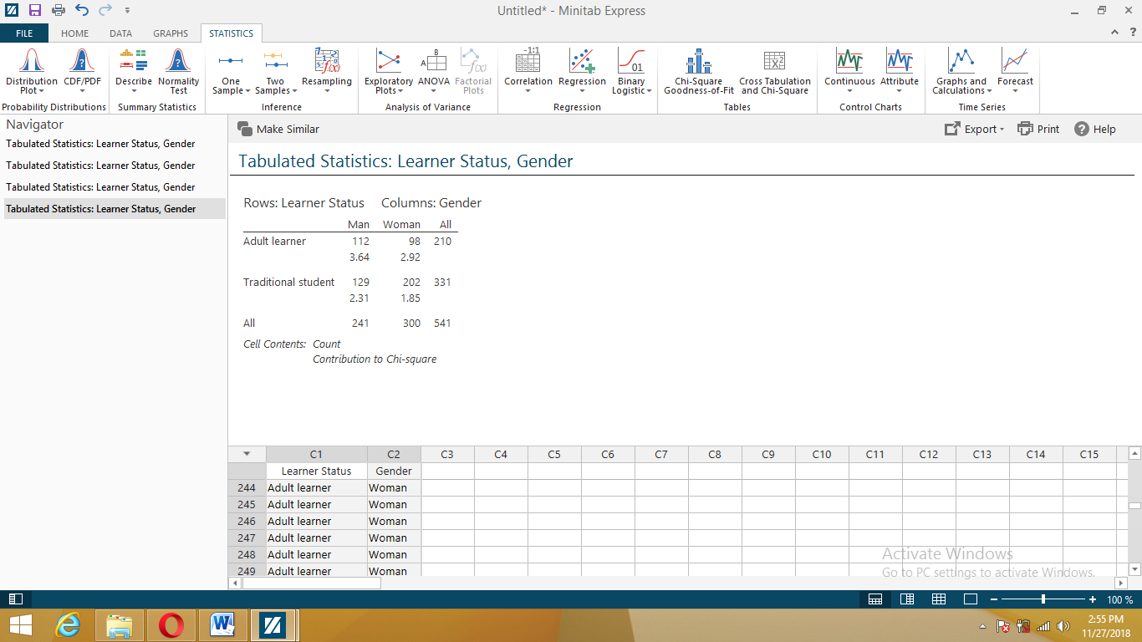
Traditional student

